A Predictive Image Coding Scheme Using a Smaller Codebook
Chin-Chen Chang, Jer-Sheng Chou, Tung-Shou Chen
Signal Processing: Image Communication, Vol. 12, No. 1, pp. 23-32, March 1998
Abstract
This paper presents a new scheme in VQ. We call it the peripheral prediction method (PPM). This method assumes that most of the image blocks in VQ are smooth.
- Introduction
• VQ
- Previous Work
• SMVQ (side-match vector quantization)
• CSMVQ (variable-rate SMVQ)
- Peripheral Prediction Method (PPM)
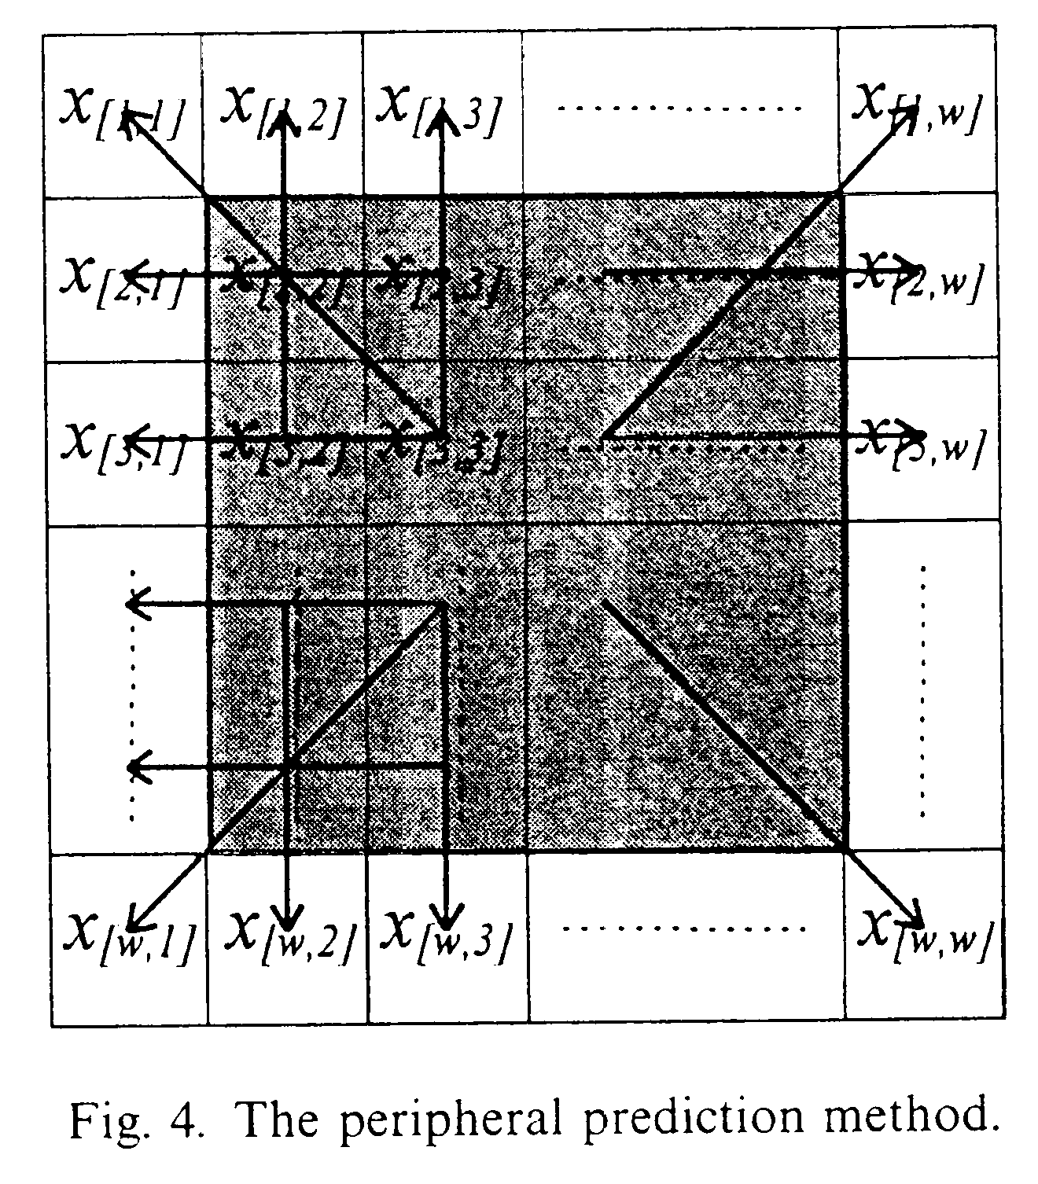
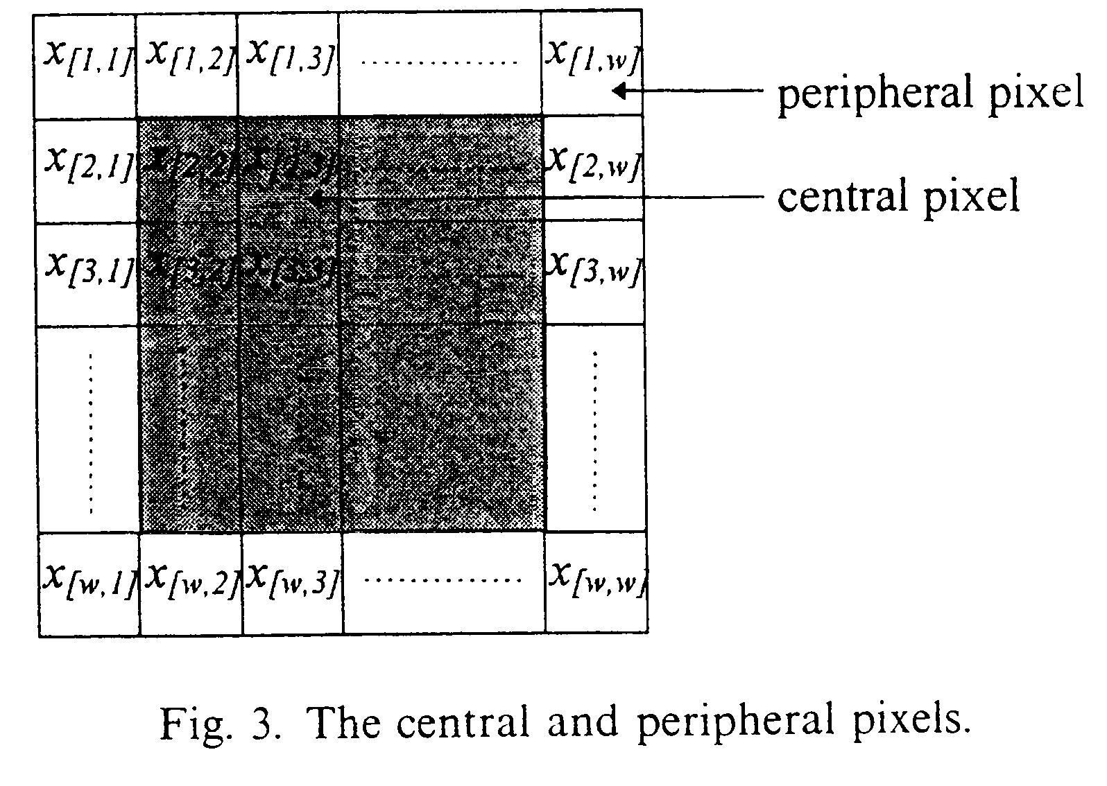

x_{[1,1]} = | x_{[2,2]}+(x_{[2,2]}–x_{[3,3]}) | = | 2·x_{[2,2]}–x_{[3,3]} |

3.1. Codebook generation phase of PPM
Use LBG algorithm to generate the codebook:
• traditional codebook
• central codebook

3.2. Encoding phase of PPM

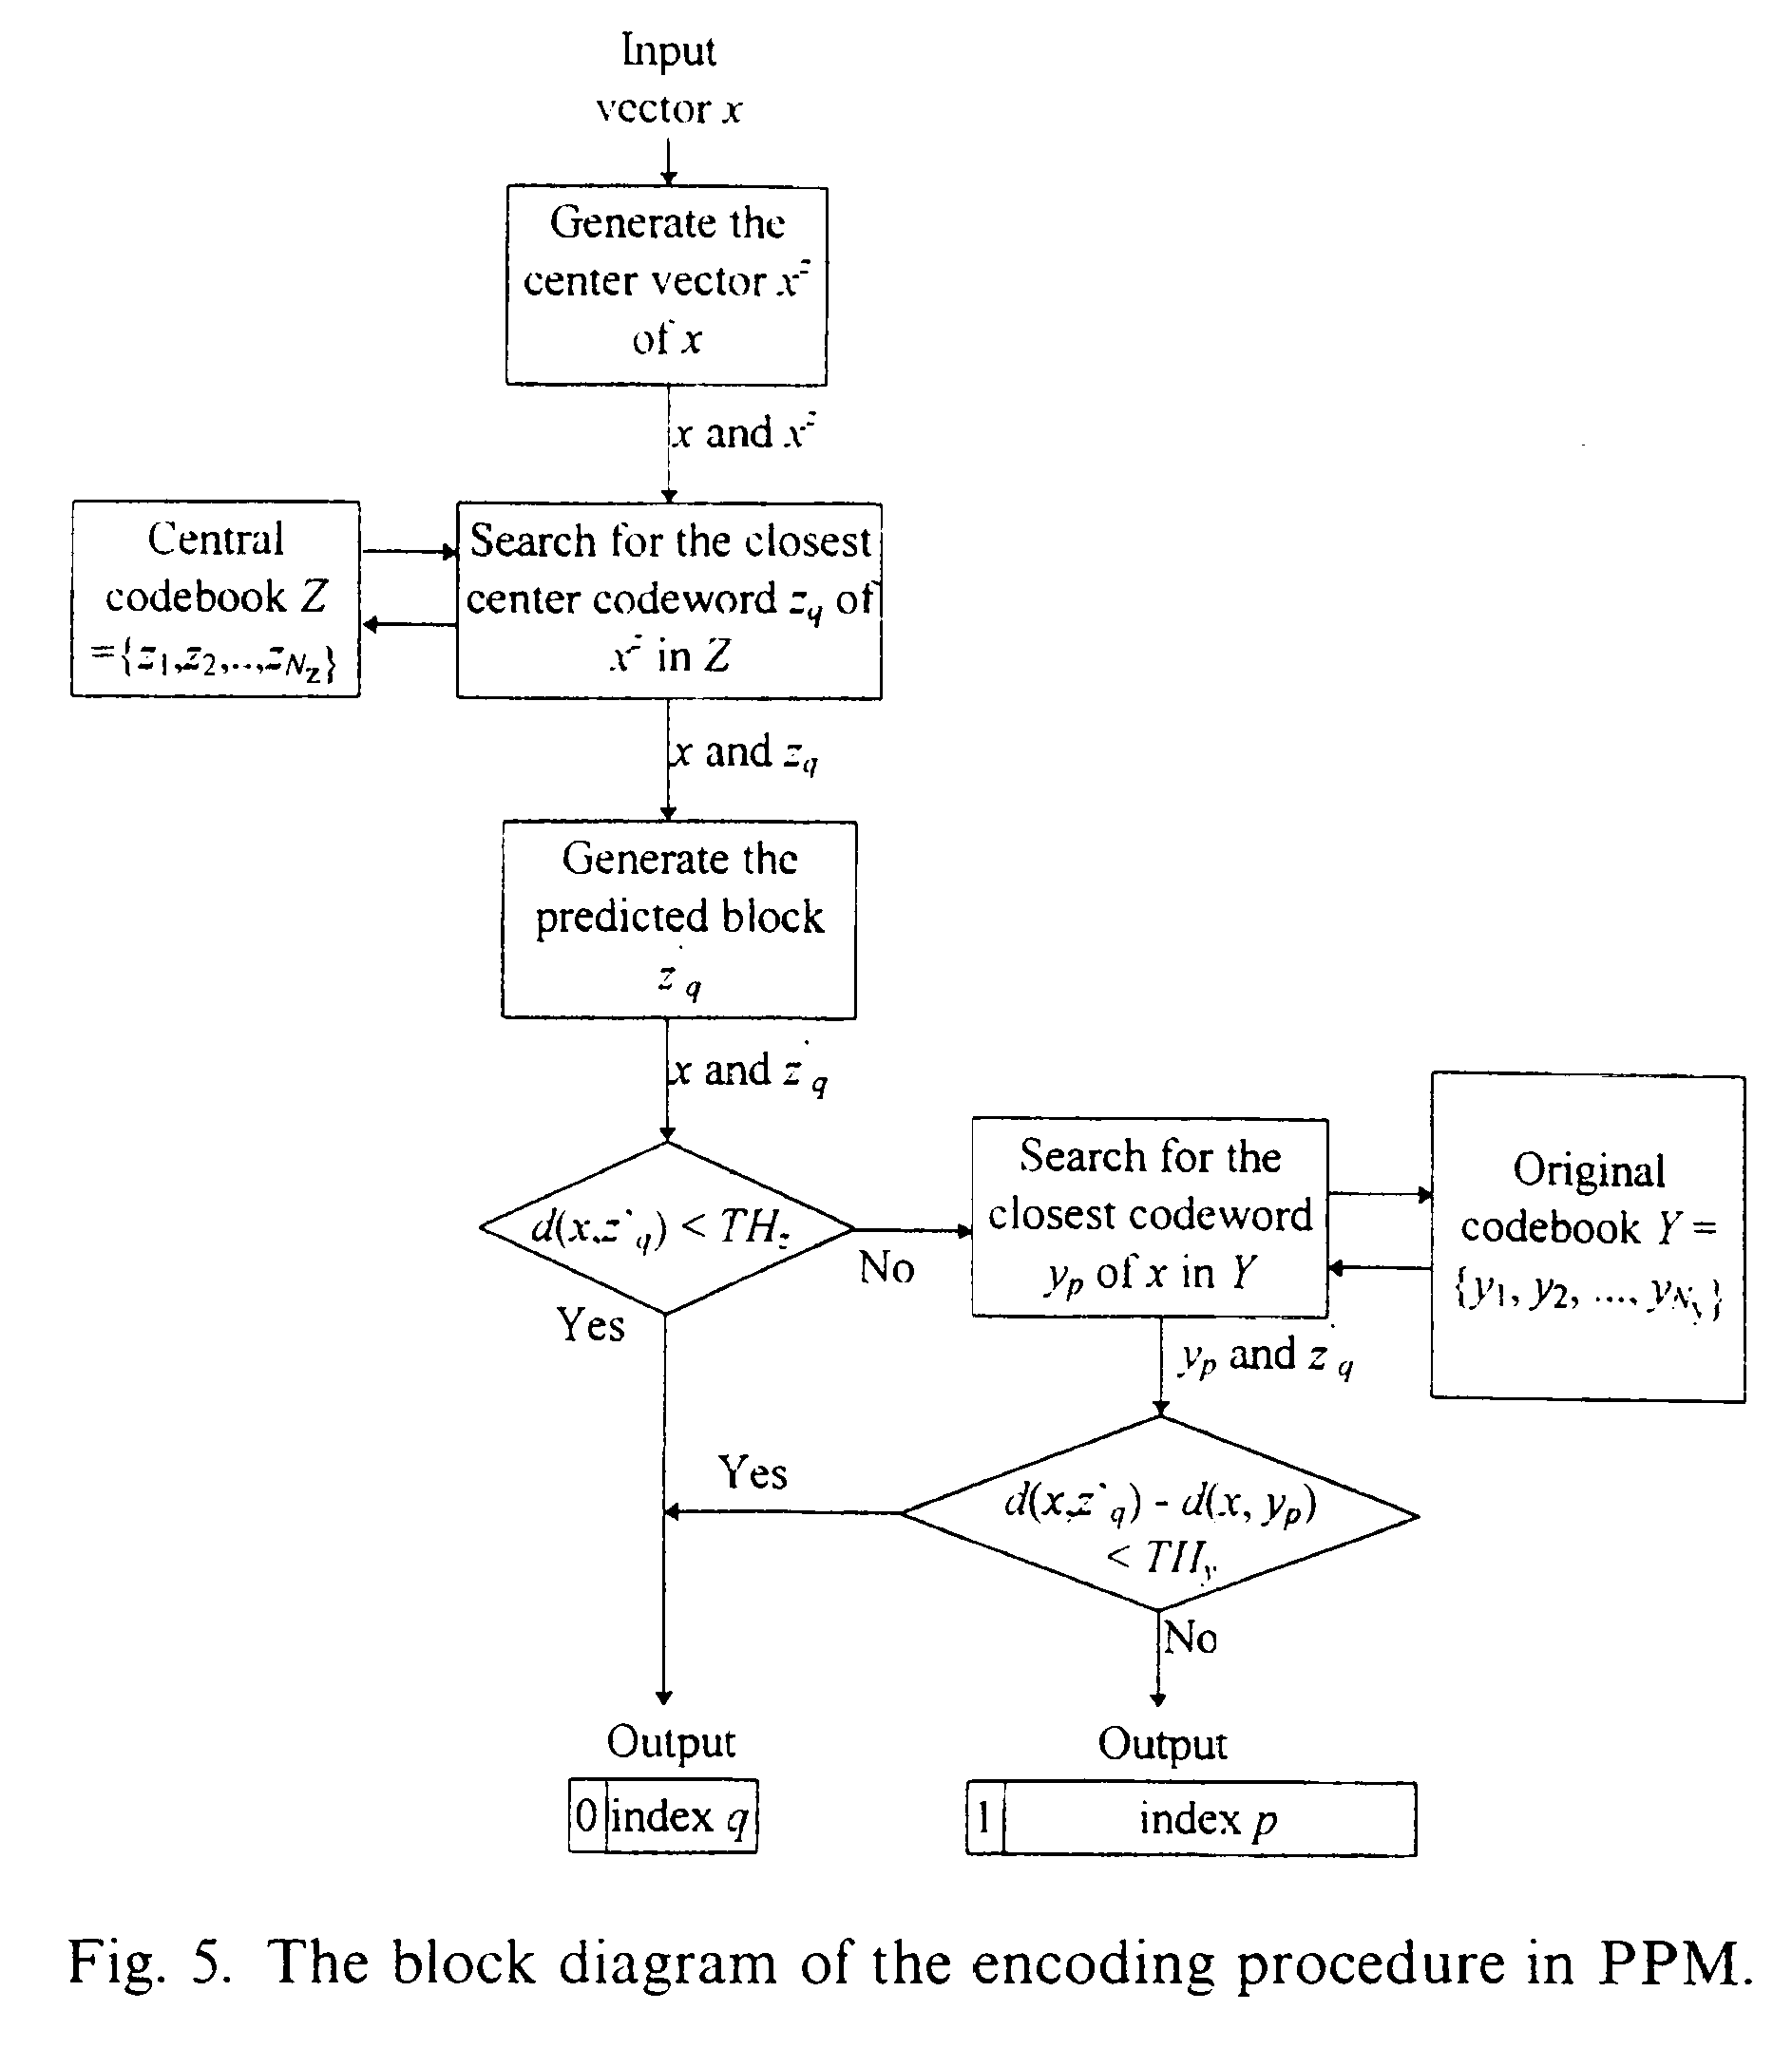

3.3. Decoding phase of PPM

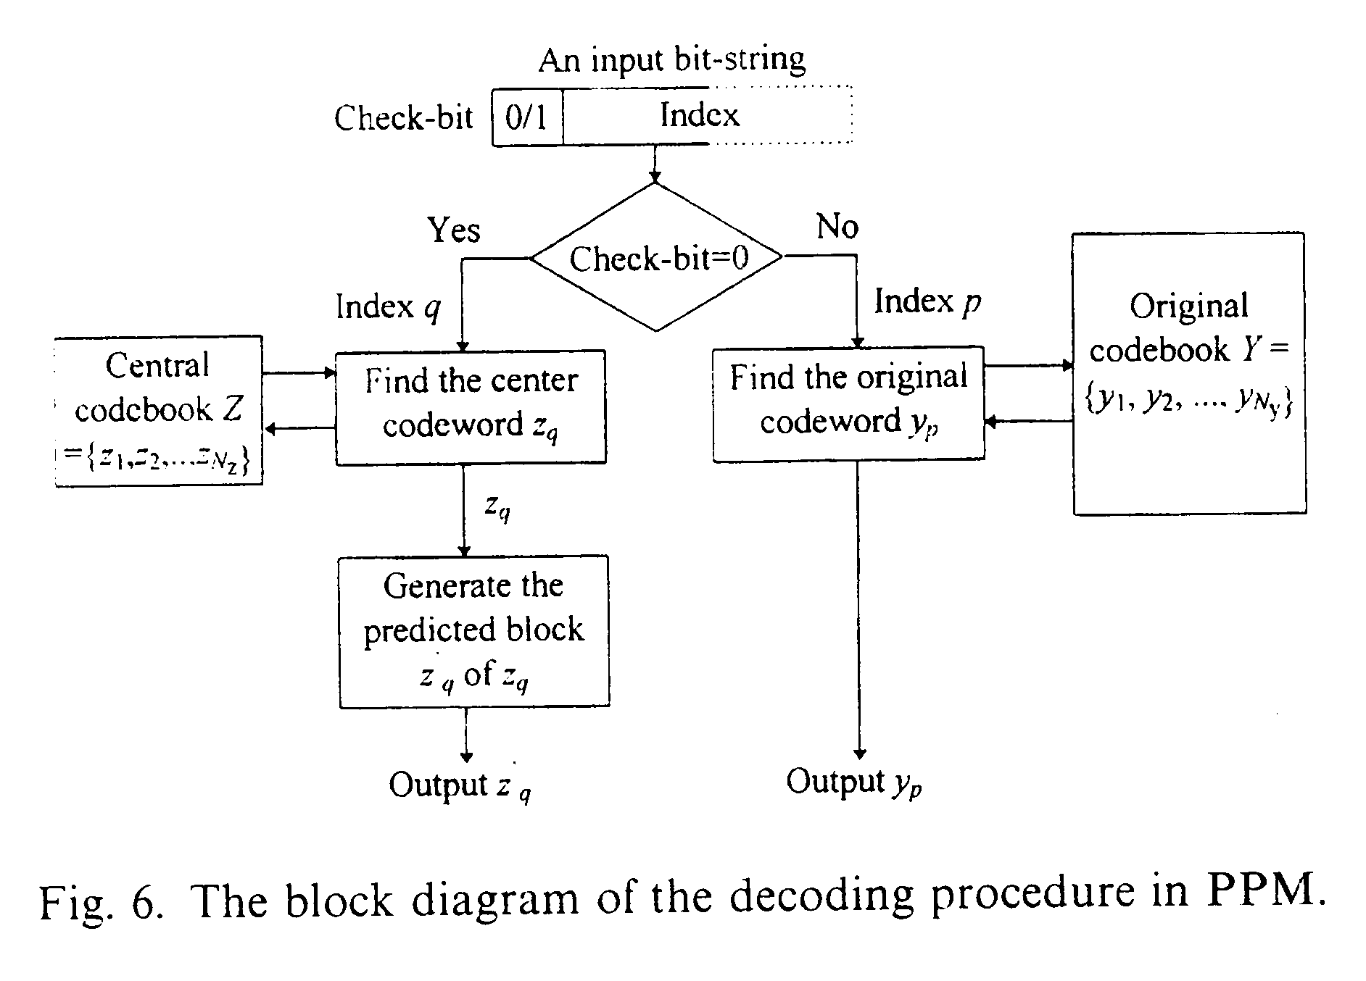
- Experimental Results

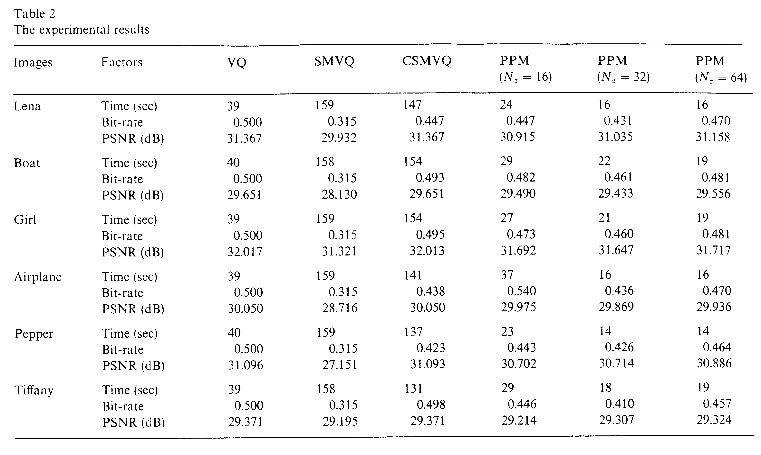
- Conclusion
PPM is better than the traditional VQ in the encoding time and bit-rate, even though PPM degrades the image quality a little. Compared to other methods, such as SMVQ and CSMVQ, PPM always at least 7 times faster than they were.
Created by : Chia-Hao Yang
Date : Sep. 11, 1998

